Homework 5
ECE 253
Mingxuan Wang A53077257
December 8, 2015

- Problem 1 Canny Edge Detection
- The original gradient magnitude image
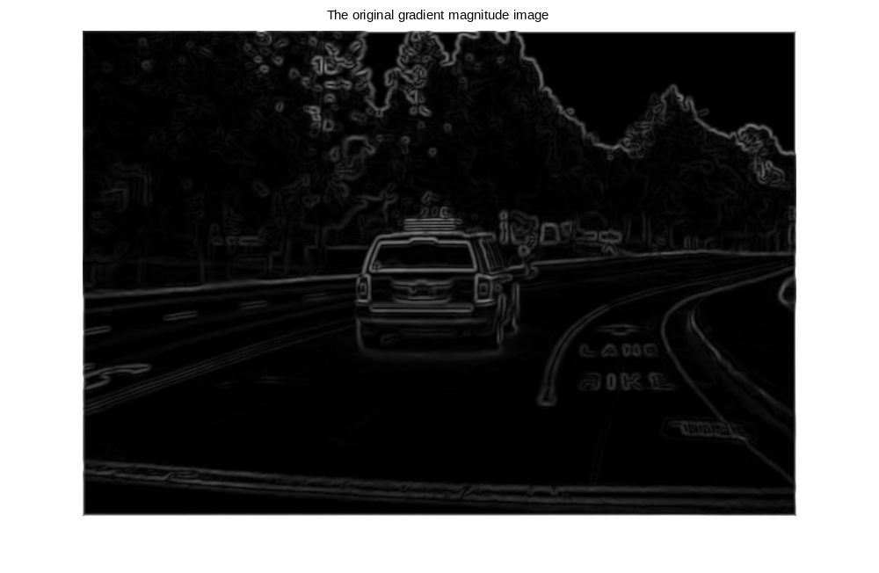
Figure 1 The original gradient magnitude image

- The image after NMS
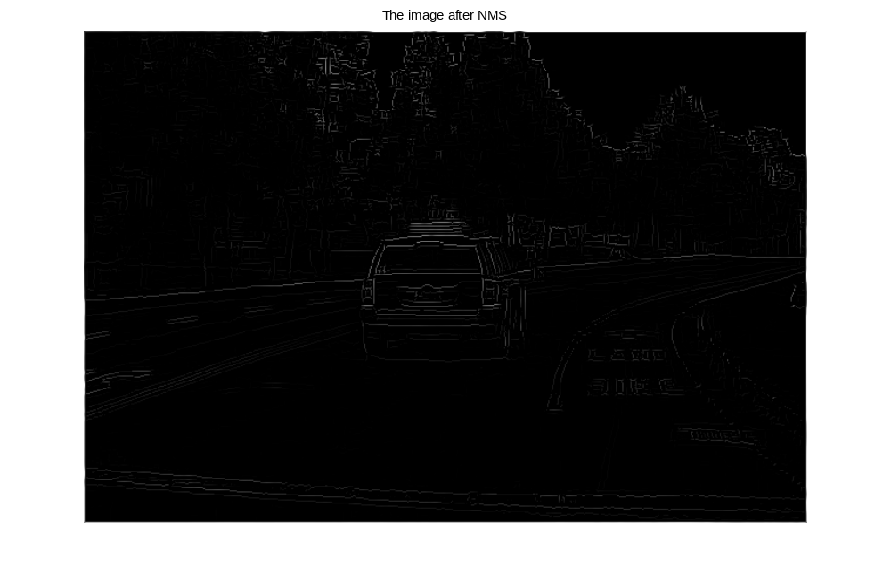
Figure 2 The image after NMS

- The ﬁnal edge image after thresholding
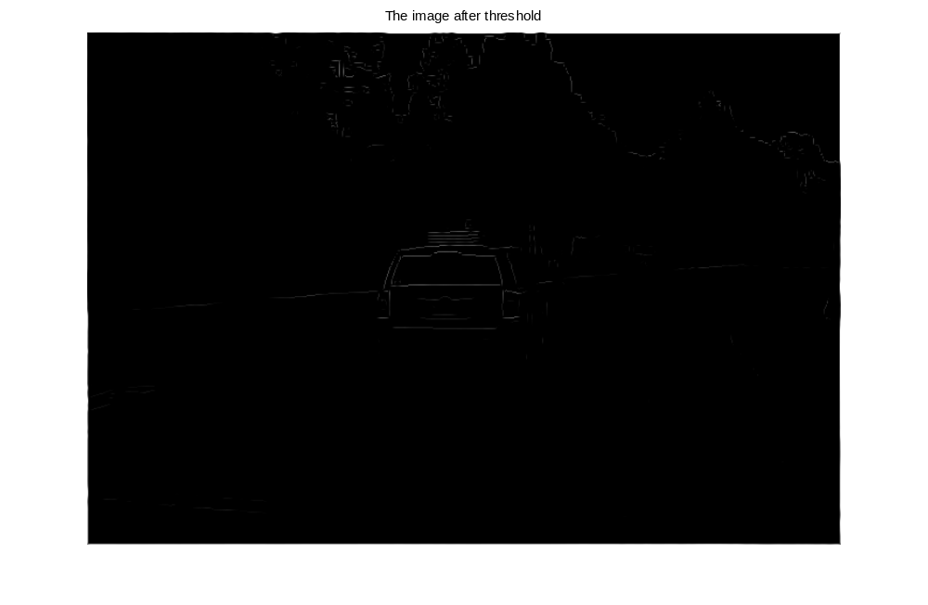
Figure 3 The image after threshold
For the image above, I used tc =180.

- Problem 2 Hough Transform
- 3 images from 2(ii):

Figure 4 original image

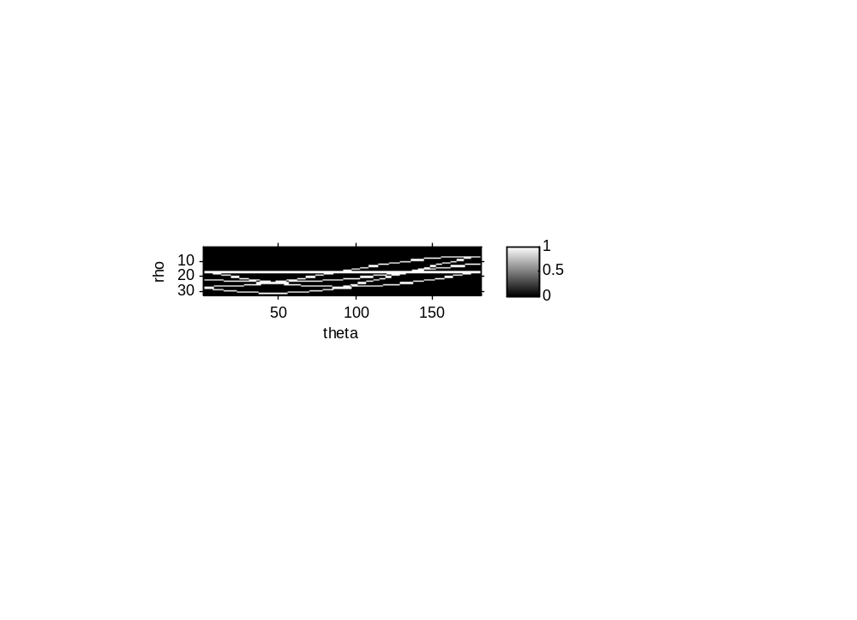
Figure 5 HT image


Figure 6 Original image with lines

- 4 images from 2(iii):

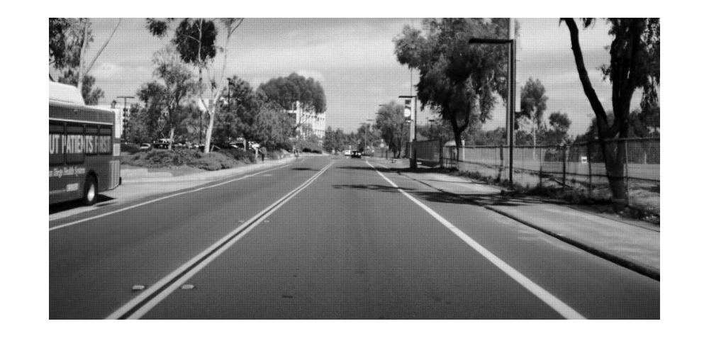
Figure 7 Original image

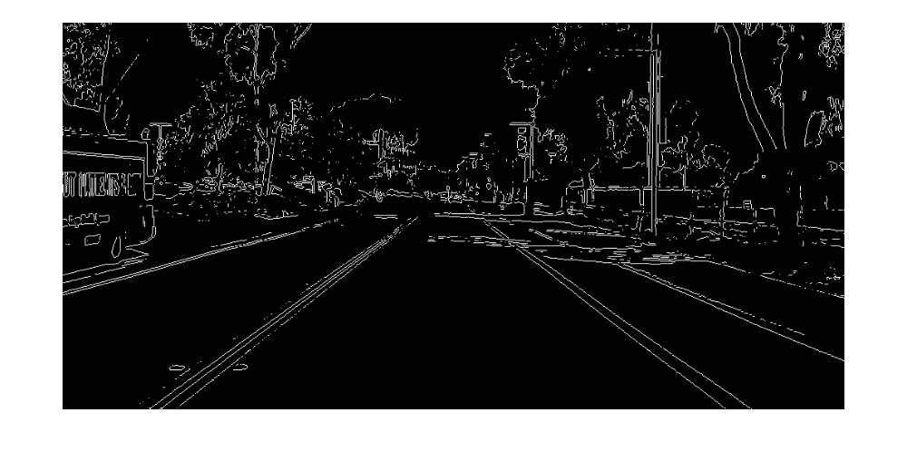
Figure 8 Binary image

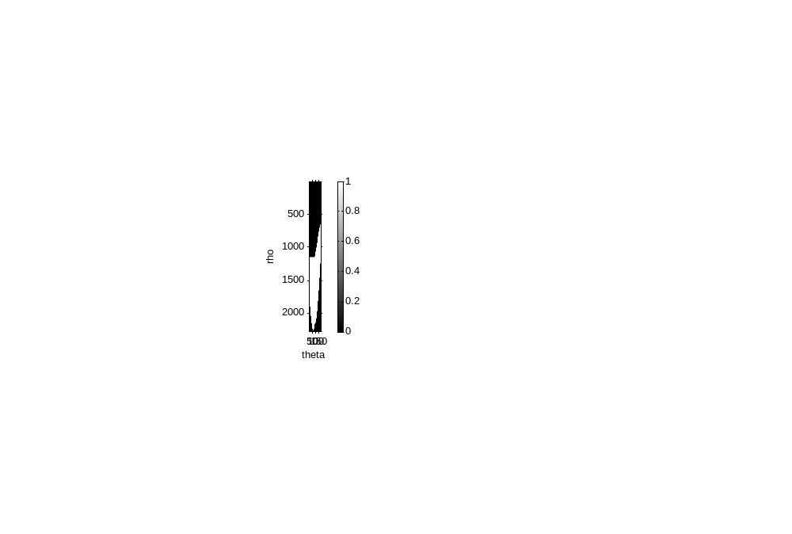
Figure 9 HT image

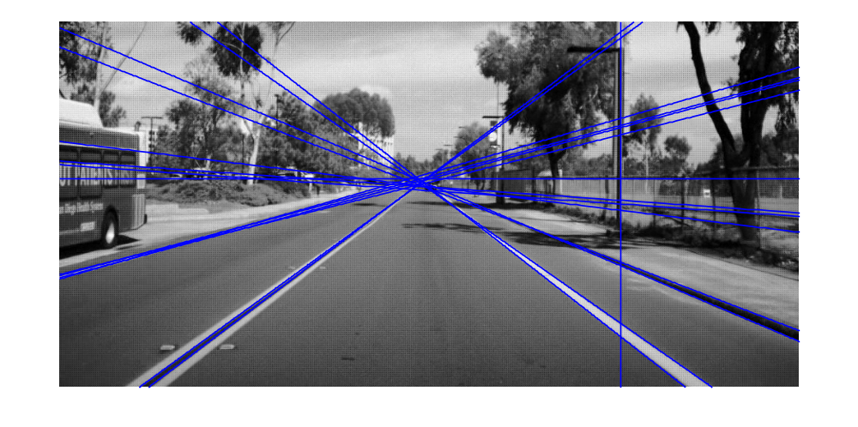
Figure 10 Original image with lines

- 1 image from 2(iv): original image with lines:
Note in this image, I used threshold as 0.82*max(HT(:))

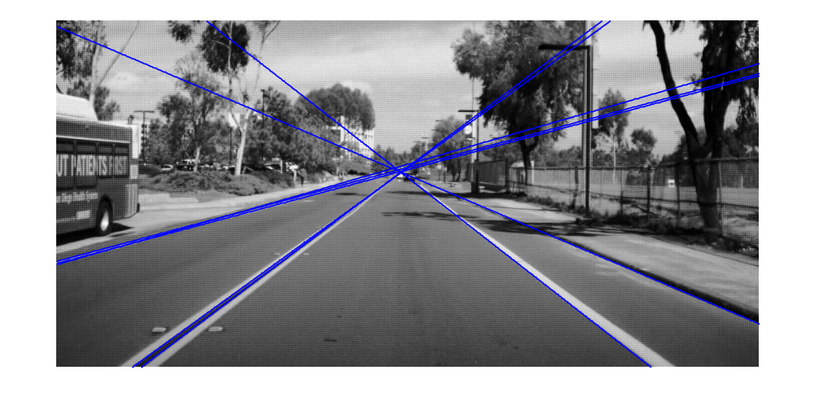
Figure 11 Original image with lines

- Problem 3 Circular Hough Transform

